**1**_ Start mysql and and use retail database

[osboxes@quickstart-bigdata ~]$ mysql -u root -pbigdata

mysql> show databases;

mysql> use retail_db;

mysql> show tables;

mysql> desc customers;

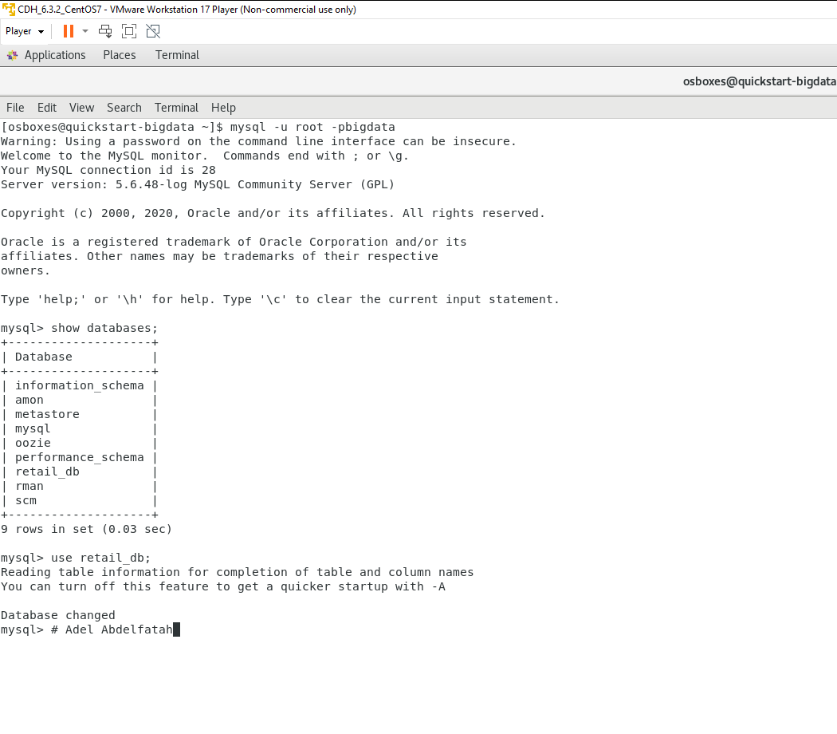

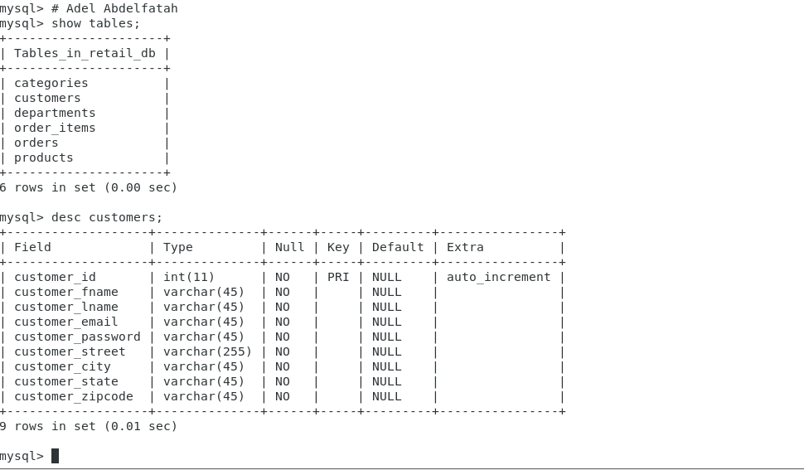

**2**_OPEN HBASE by **hbase shell**

[osboxes@quickstart-bigdata ~]$ hbase shell

hbase(main):003:0> create 'customers', 'CustomerInfo', 'ContactInfo','miscellaneous'

hbase(main):003:0>list

hbase(main):005:0> describe 'customers'

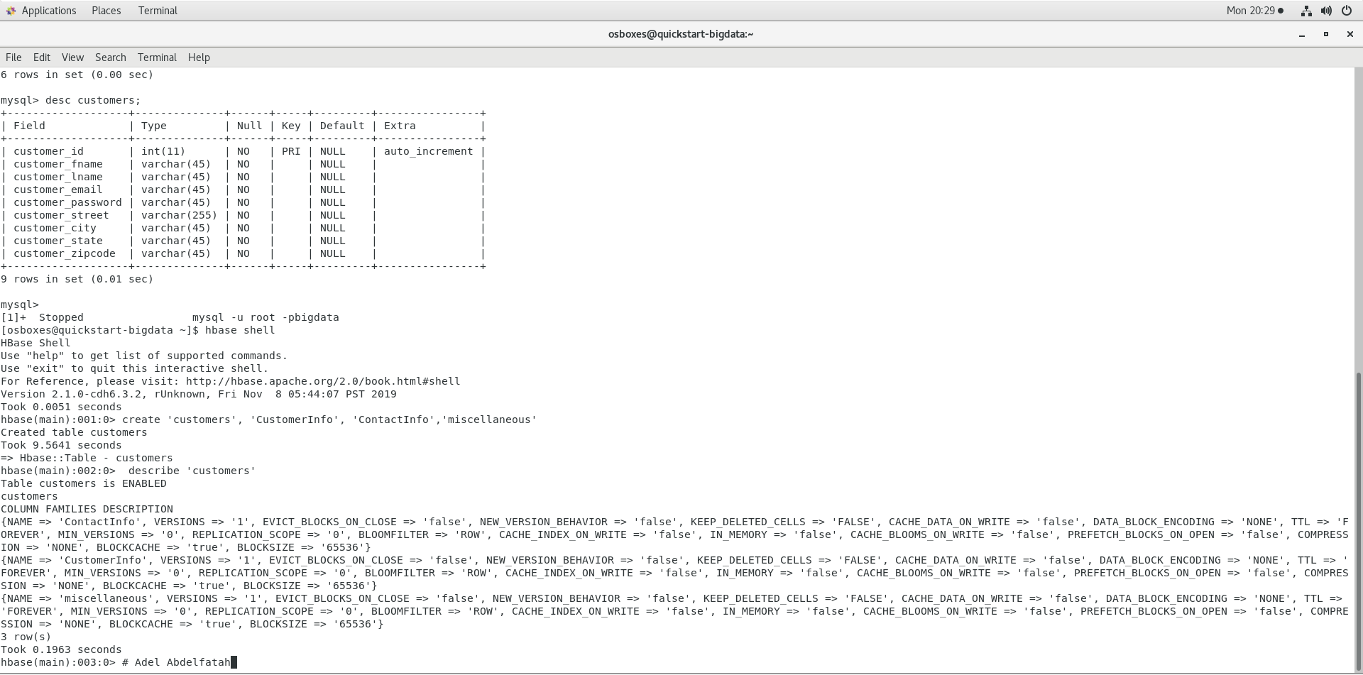

***3****_Import data from MySQL* ***retail_db.customers*** *table*

[osboxes@quickstart-bigdata ~]$ sqoop import --connect jdbc:mysql://192.168.83.129/retail_db --username root --password bigdata --table customers --columns "customer_id, customer_fname, customer_lname, customer_email, customer_password" --hbase-table customers --column-family CustomerInfo --hbase-row-key customer_id -m 1

[osboxes@quickstart-bigdata ~]$sqoop import --connect jdbc:mysql://192.168.83.129/retail_db --username root --password bigdata --table customers --columns "customer_id, customer_street, customer_city, customer_state, customer_zipcode" --hbase-table customers --column-family ContactInfo --hbase-row-key customer_id -m 1

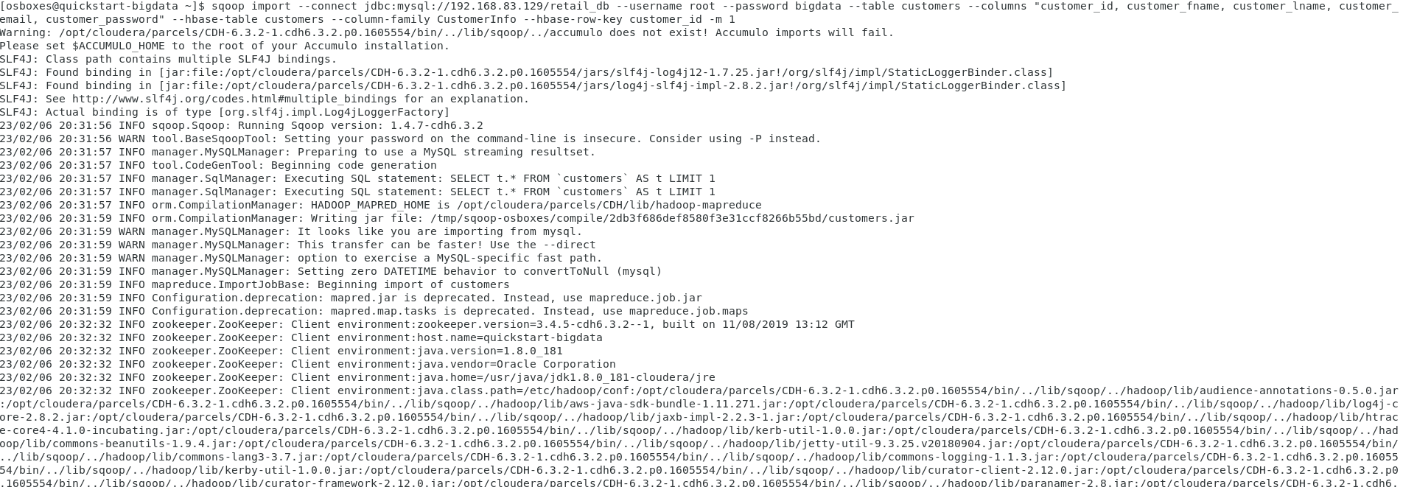

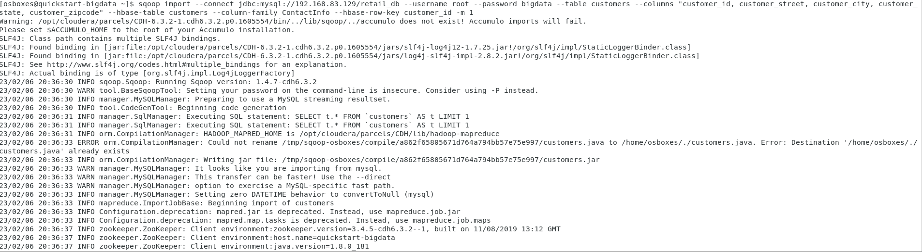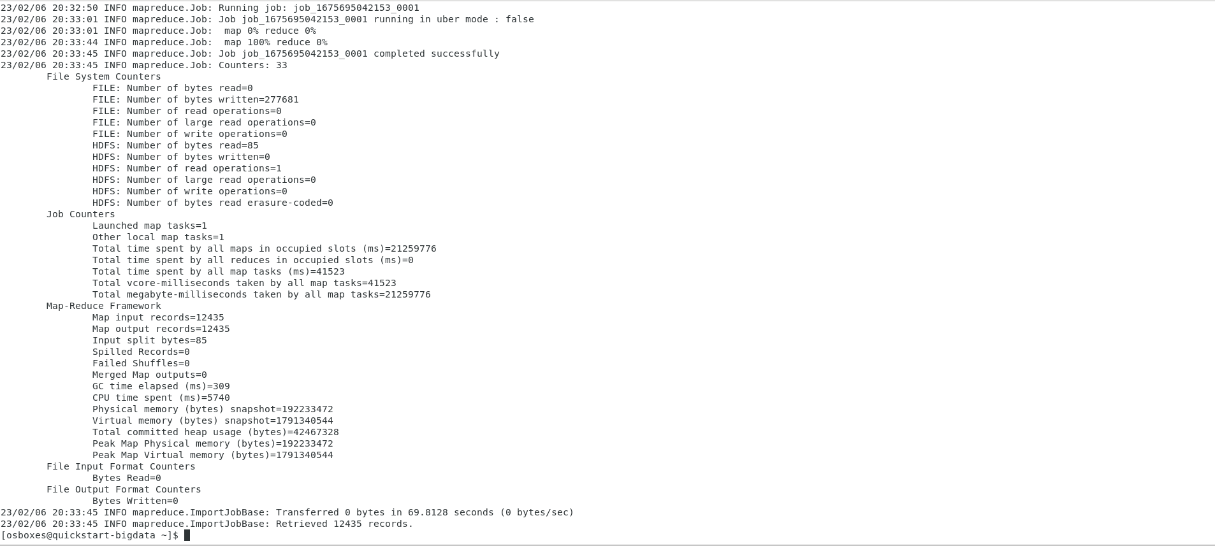

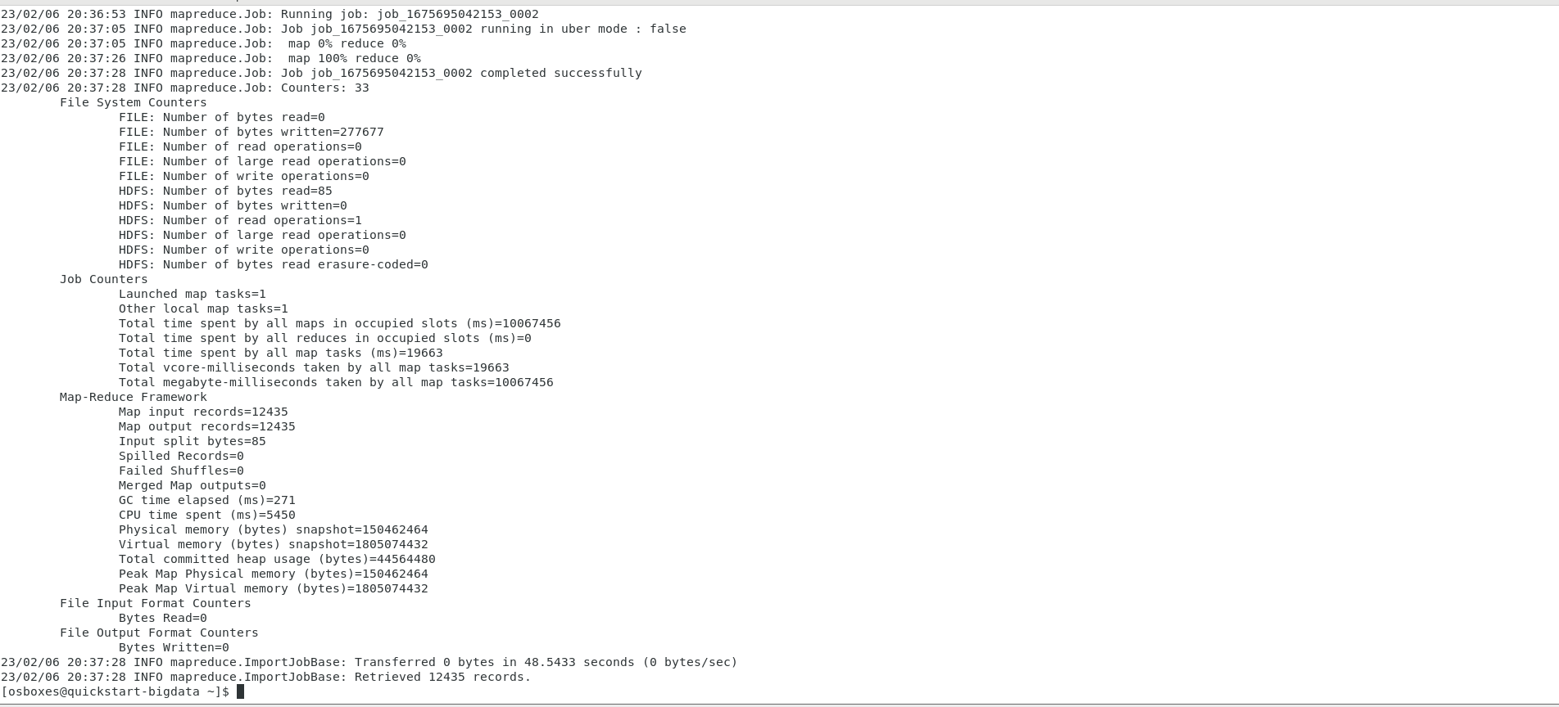

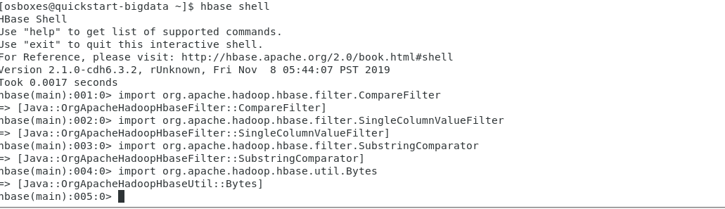

**4 : Scan Table and filter**

scan 'customers', { COLUMNS => 'ContactInfo:customer_state', LIMIT => 20, FILTER => "ValueFilter( =, 'binaryprefix:NY' )" }

scan 'customers', { COLUMNS => 'ContactInfo:customer_state', LIMIT => 20, FILTER => "ValueFilter( =, 'binaryprefix:VA' )" }

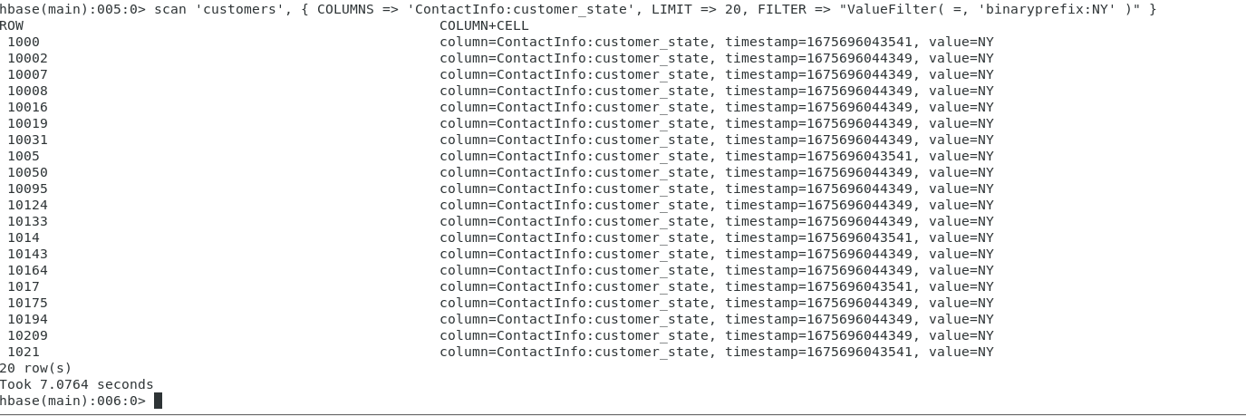

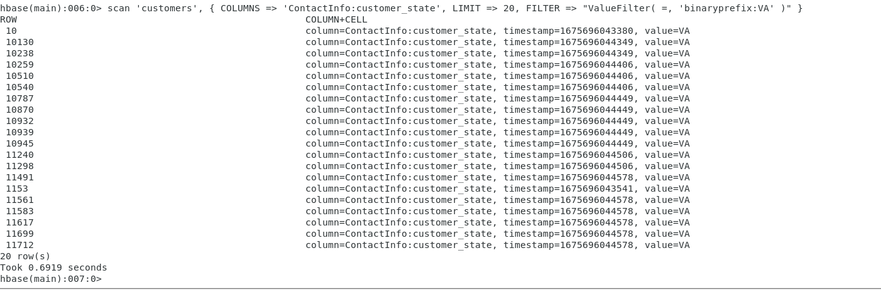

**5_: Demonstrate the application by PUT command and GET command**

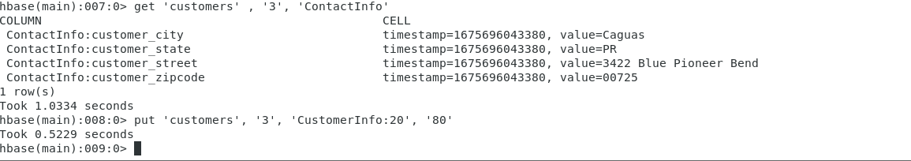Get to get values by table name and row hey and column family

Put to insert values by table name and row hey and column family